Corded Button Switches
Corded button switches allow people with physical disabilities to activate and access assistive technology and mainstream devices in their environment, such as smartphones, tablets and computers.
These switches might be helpful for persons with limited upper-body mobility resulting from spinal cord injuries, multiple sclerosis, ALS, muscular dystrophy, cerebral palsy, brain injuries, stroke, or amputation.
Type of accessory: Ability Switches
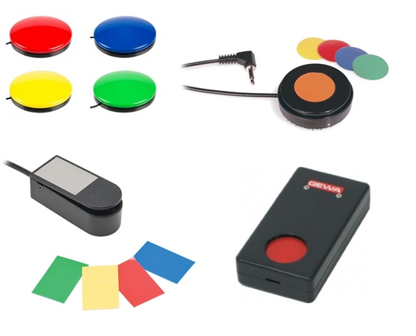

How do you use these accessories?
Press the button switch to select and access apps and functions in your smart device, including call and messaging services.
Pressing a button switch closes an electrical circuit, which activates the equipment it is connected to via the 3.5mm plug. A Bluetooth switch interface is needed in order for this device to connect to a smartphone or tablet.
An example of how to use these devices can be seen in the following video:
Example of Switch use on iOS Accessible Apps

These accessories connect to phones via:
Audio Jack: No
BlueTooth: Yes (By using a Bluetooth Interface Switch)
WiFi: No
Micro USB: No
Other: No

Is there any other piece of equipment required for this accessory to work properly with a phone?
Yes. Corded button switches do not have Bluetooth connectivity, which is usually required to connect to a smartphone or tablet; therefore you need a “Bluetooth Switch Interface” which is a device that acts as a connection bridge between your corded switch and your smartphone or tablet.
Some Bluetooth switch interfaces in the market are Tecla Shield DO, Tecla-e and Pretorian Applicator switch interface.

Compatibility:
The compatibility of a corded button switch depends on the Bluetooth Switch Interface used to connect to the phone or tablet.

Popular corded switches available in Australia:

AbleNet Big Buddy Switch
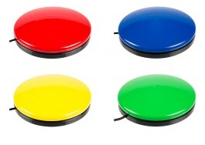
The Big Buddy Switch is a large wired switch featuring an 11.5 cm (4.5-inches) activation surface that provides an auditory click and tactile feedback. It requires 150 grams of force to activate.
You can buy this accessory from Zyteq, Spectronics and Technical Solutions.
More information on:
Big Buddy Switch Webpage

AbleNet Big Red Twist
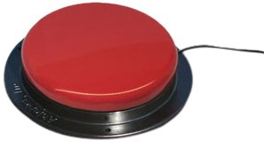
The Big Red switch provides a large 12.7cm (5 inch) activation surface that activates with 156 grams of force. Included are red, blue, yellow, and green interchangeable switch tops and a snap on clear symbol holder.
You can buy this accessory from Zyteq, Spectronics, Technical Solutions, and Communicate AT.
More information om:
Big Red Twist Switch Webpage

AbleNet Buddy Button
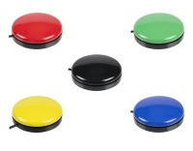
The Buddy Button is a wired switch featuring a 6.4 cm (2.5 inches) activation surface that provides an auditory click and tactile feedback. It requires 142 grams of force to activate.
You can buy this accessory from Zyteq, Spectronics, Technical Solutions and Communicate AT.
More information on:
Buddy Button Switch Webpage

AbleNet Mini Cup Switch
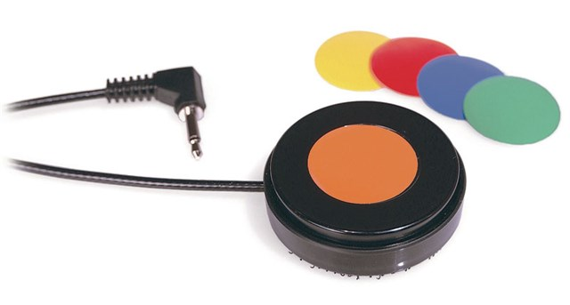
The Mini Cup switch features a 2.5 cm (1-inch) activation surface that provides auditory click and tactile feedback, and requires 130 grams of force to activate.
You can buy this accessory from Spectronics and Technical Solutions.
More information on:
Mini Cup Switch Webpage

Inclusive Technology Finger Button 30
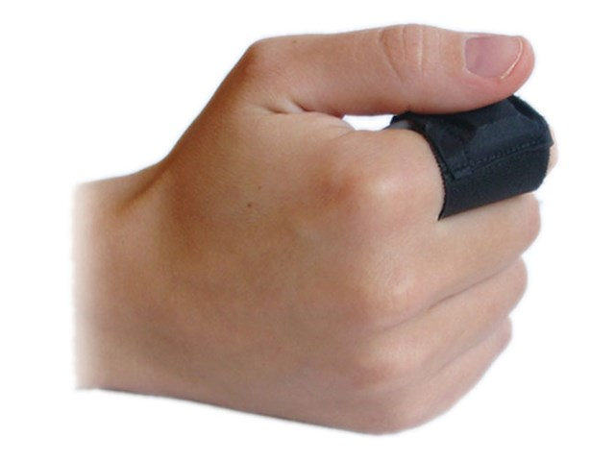
The Finger Button 30 wraps around the user's finger, has an activation area of 10mm, requires 75 grams of force to activate and provides tactile feedback.
You can buy this accessory from Zyteq and Spectronics.
More information on:
Finger Button 30 Switch Webpage

AbleNet Micro Light Touch Switch
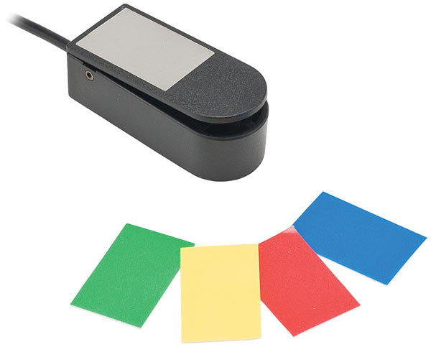
The Micro Light switch is activated by pressing down on the top surface with a feather light touch. It is 4.5cm x 1.3cm x 2cm of activation surface and only requires 10 grams of force. It provides auditory click and tactile feedback.
You can buy this accessory from Zyteq, Spectronics, Technical Solutions and Communicate AT.
More information on:
Micro Light Touch Switch Webpage

Origin Instruments Orby Switch
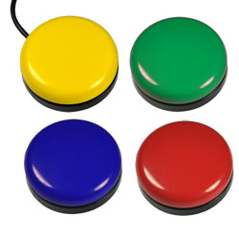
The Orby Switch has a smooth circular design that is 6.4 cm (2.5-inches) in diameter and less than 2.5 cm (1-inch) tall. A simple press anywhere on the top will provide a switch closure with audible feedback.
You can buy this accessory from Spectronics.
More information on:
Orby Switch Webpage

AbleNet Trigger Switch
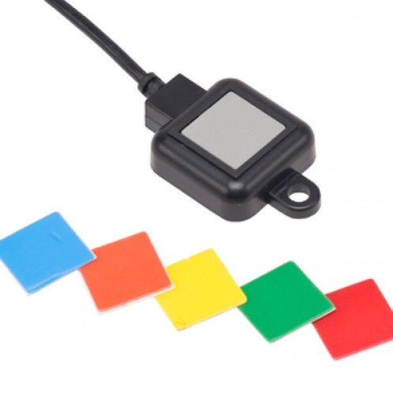
The Trigger switch is a waterproof and dust-proof switch that is designed to meet rugged needs of wheelchair users. Pressing the 1.3cm x 1.3cm surface with 300 grams of force will activate the switch. It provides auditory click and tactile feedback.
You can buy this accessory from Spectronics.
More information on:
Trigger Switch

Pykobutton
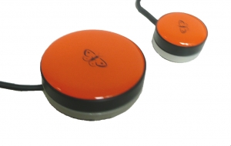
Pikobutton is a very sensitive, waterproof and durable switch that gives gentle tactile and auditory feedback upon activation. Available in many colours, this device comes in two sizes with a 30mm or 50 mm diameter and requires 125 grams of force to activate.
You can buy this accessory from Zyteq.
More information on:
Pikobutton Webpage

GEWA Pushbutton Switch
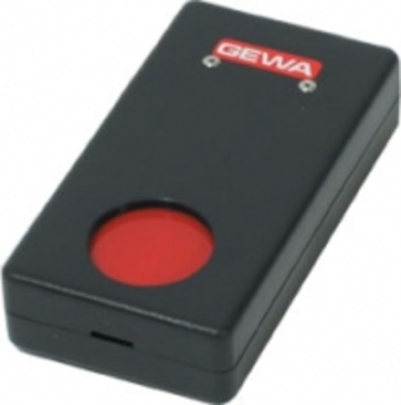
The pushbutton switch is a snap-action switch which is located in a 34mm (1.25 inches) diameter recess. It works well for a movement which can be stabilised on the black casing around the active switch plate. Requires 50g force to activate.
You can buy this accessory from Zyteq.
More information on:
Pushbutton Switch Webpage

Pretorian UK Smoothie 125 Switch
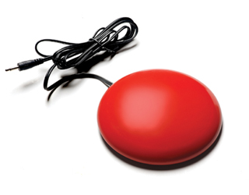
The Smoothie 125 is a low profile switch which has a 125mm diameter and provides tactile feedback. It’s low profile and angled design means the user can rest their hand on the desk in front of the unit and simply ‘roll’ it towards the switch when required. It comes in a variety of colors (red, yellow, blue, green).
You can buy this accessory from Zyteq and Communicate AT.
More information on:
Smoothie 125 Switch Webpage

AbleNet Jelly Bean Twist
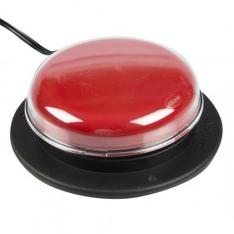
The Jelly Bean twist features a 6.4 cm (2.5-inches) activation surface that provides an auditory click and tactile feedback, and requires 71 grams of force to activate.
You can buy this accessory from Zyteq, Spectronics, Technical Solutions and Communicate AT.
More information on:
Jellybean Switch Webpage

AbleNet Specs Switch
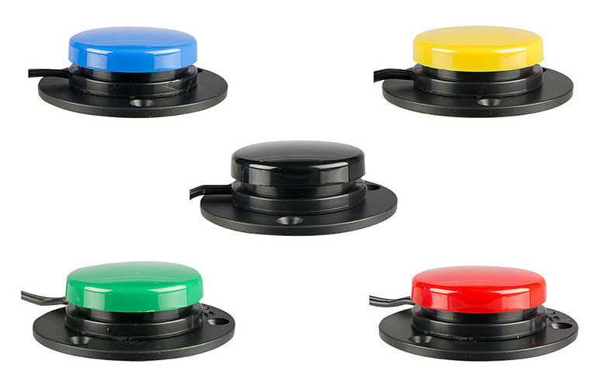
The AbleNet Specs Switch is a compact wired switch featuring a 3.5 cm (1.4 inches) activation surface that provides an auditory click and tactile feedback. It requires 100 grams of force to activate. This device comes with three bases: flange base, flush base, and a strap adaptable base, including a 61 cm (24-inch) strap. This means the switch can be adapted to attach to different surfaces to better suit the needs of the individual.
You can buy this accessory from Zyteq, Spectronics, Technical Solutions and Communicate AT.
More information on:
Specs Switch Webpage

Pillow Switch
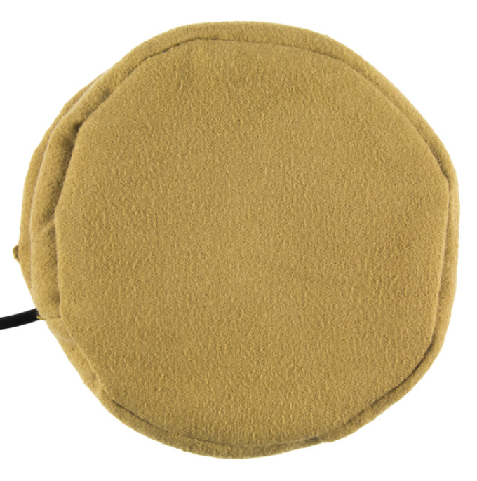
The AbleNet Pillow Switch has a smooth and soft foam activation surface, 8cm in diameter. The switch is suitable for head or cheek activation. The switch includes a safety pin and Velcro strap, allowing the switch to be fastened to a pillow or wheelchair cushion.
You can buy this accessory from Zyteq and Spectronics.
More information on:
Pillow Switch Webpage

Is there any training available for these accessories?
Training and demonstrations might be available directly from the retailers.
Some of these accessories might be displayed and available for demonstrations at Independent Living Centre Australia. Please contact ILC by calling 1300 885 886 for further information.

